|  |
| --- |
| **Domain & FileServer Share configuration** |

Preconfigured items 1

Deploying DC 1

Configuring the DC 2

Step 1: Server Name 2

Step 2: Install DC 3

Step 3: Configure DC 5

FINAL STEPS 10

Important Notes 10

# Preparations

* **Copy, the latest version of the scripts (MESO)** to the server in the C:\scripts folder.
* **The File server needs an ESET FILE AntiVirus installation**

# Deploying FileServer or AppServer

* Start powershell with elevated rights
* Navigate to c:\scripts
* Execute “.\Configure-FileServer”

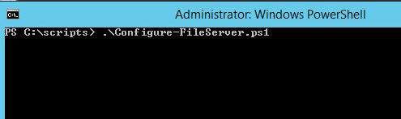

Give in the drive letter for the creation of the shares :

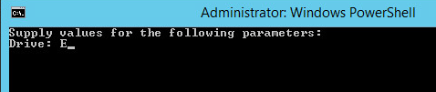

Choose A for ApplicationServer Shares or F for Fileserver Shares

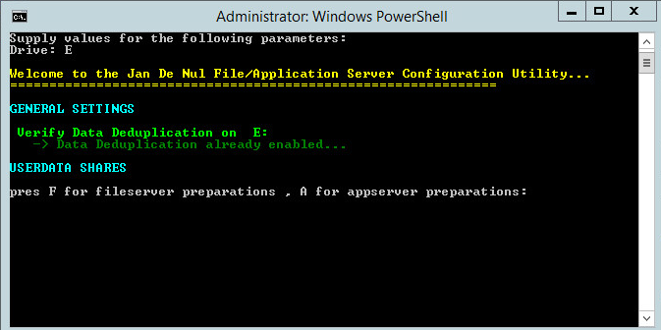

Script will run and create folders/shares

